There is a **simple directed graph** with n nodes labeled from 0 to n - 1. The graph would form a **tree** if its edges were bi-directional.

You are given an integer n and a **2D** integer array edges, where edges[i] = [ui, vi] represents a **directed edge** going from node ui to node vi.

An **edge reversal** changes the direction of an edge, i.e., a directed edge going from node ui to node vi becomes a directed edge going from node vi to node ui.

For every node i in the range [0, n - 1], your task is to **independently** calculate the **minimum** number of **edge reversals** required so it is possible to reach any other node starting from node i through a **sequence** of **directed edges**.

Return *an integer array* answer*, where* answer[i] *is the* ***minimum*** *number of* ***edge reversals*** *required so it is possible to reach any other node starting from node* i *through a* ***sequence*** *of* ***directed edges****.*

**Example 1:**

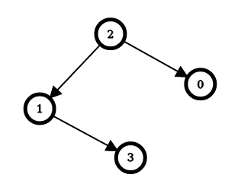

Input: n = 4, edges = [[2,0],[2,1],[1,3]]  
Output: [1,1,0,2]  
Explanation: The image above shows the graph formed by the edges.  
For node 0: after reversing the edge [2,0], it is possible to reach any other node starting from node 0.  
So, answer[0] = 1.  
For node 1: after reversing the edge [2,1], it is possible to reach any other node starting from node 1.  
So, answer[1] = 1.  
For node 2: it is already possible to reach any other node starting from node 2.  
So, answer[2] = 0.  
For node 3: after reversing the edges [1,3] and [2,1], it is possible to reach any other node starting from node 3.  
So, answer[3] = 2.

**Example 2:**

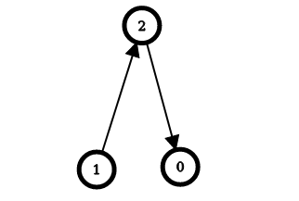

Input: n = 3, edges = [[1,2],[2,0]]  
Output: [2,0,1]  
Explanation: The image above shows the graph formed by the edges.  
For node 0: after reversing the edges [2,0] and [1,2], it is possible to reach any other node starting from node 0.  
So, answer[0] = 2.  
For node 1: it is already possible to reach any other node starting from node 1.  
So, answer[1] = 0.  
For node 2: after reversing the edge [1, 2], it is possible to reach any other node starting from node 2.  
So, answer[2] = 1.

**Constraints:**

* 2 <= n <= 105
* edges.length == n - 1
* edges[i].length == 2
* 0 <= ui == edges[i][0] < n
* 0 <= vi == edges[i][1] < n
* ui != vi
* The input is generated such that if the edges were bi-directional, the graph would be a tree.